

**Faculty Of Engineering and Technology**

**Electrical And Computer Engineering Department**

**Linux Lab**

**ENCS3130**

**Shell Scripting Project Report**

**Students:**

Amal Ziad_1192141

Zainab Shaabneh_1182820

**Instructors:**

Mohammad Jubran

Khader Mohammad

**Sections**: 1 & 2

**Date:**

26/11/2021

# Abstract

The aim of this project is to be more familiar with shell script programming by building a shell script that does a simple program which does some operations in contact management system.

**Contents**

Abstract 2

General Idea : 4

Task 1 (Adding contact operation): 5

Task 2(Sorting and Listing all contacts): 6

Task 3(Searching for contact): 7

Task 4(Edit a contact): 8

Task 5(Delete a contact): 9

Task 6(Exiting the program): 11

Conclusion: 12

# General Idea:

In this project, first we made contacts management menu that do some operations as shown in fig.0.1, and apply it on a file called contacts.txt which contains data and information.

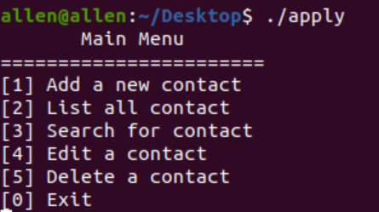

Fig.0.1

As this was done in shell script called apply in Desktop as shown in fig.0.2. the while loop is to keep the menu to continue appearing unless 0 is not applied. And read command to ask user to enter option.

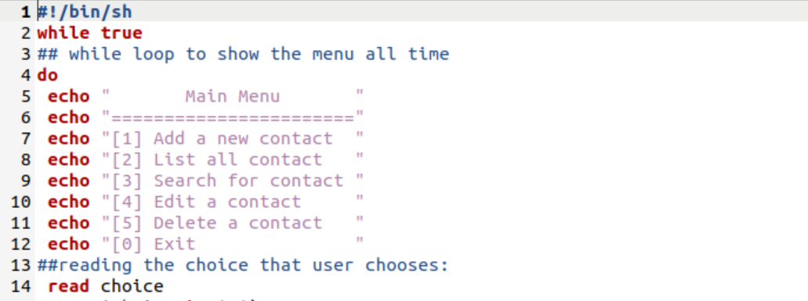

Fig.0.2

Also we created file called contacts.txt using $gedit contacts.txt command, and filled it as shown in fig.0.3.

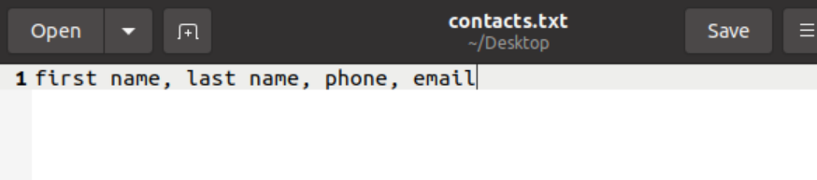

Fig.0.3

# Task 1 (Adding contact operation):

When user enters ‘1’ which is for adding a new contact, the program asks first for first name and last name then phone number, the phone number must be 9 or 10 digits so we used the command ‘x=$( echo $phone | wc –c )’ to count the digits of the phone number and store it in ‘x’, then comparing if the value of x not equal 9 or 10 then display an error message and ask user to enter t again, as shown in fig.1.1.

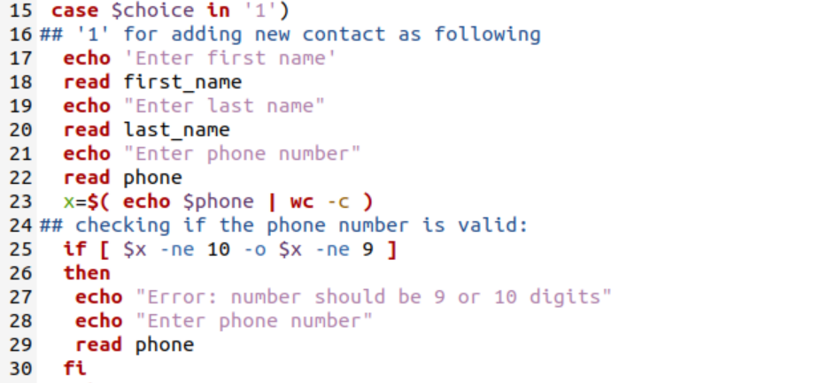

Fig.1.1

Then ask user for email and as we know the email must include ‘@’ sign. To get it, the program uses the command “a=$(echo $email | grep ‘@’)” to check if @ is exists then comparing if the content of is equal 0 then it’s true ( the email includes @), if not, the email doesn’t include @, then display an error message and ask user again to enter email. Finally print all accepted data and store the result in contacts.txt file. As shown in fig.1.2

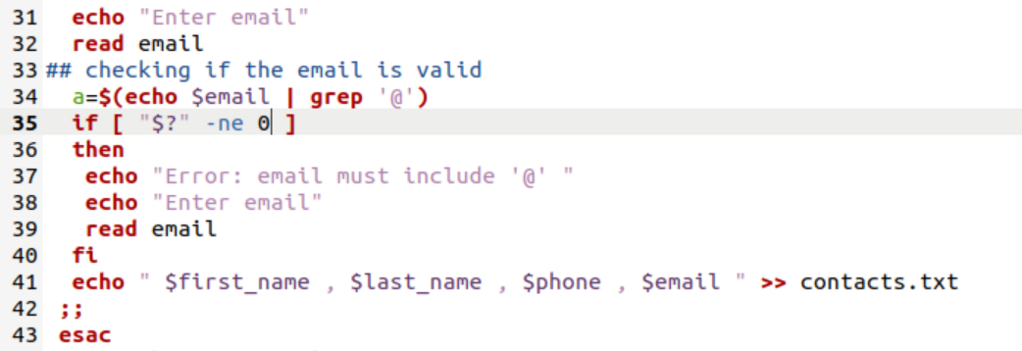

Fig.1.2

After execting the program we got the following result shown in fig.1.3

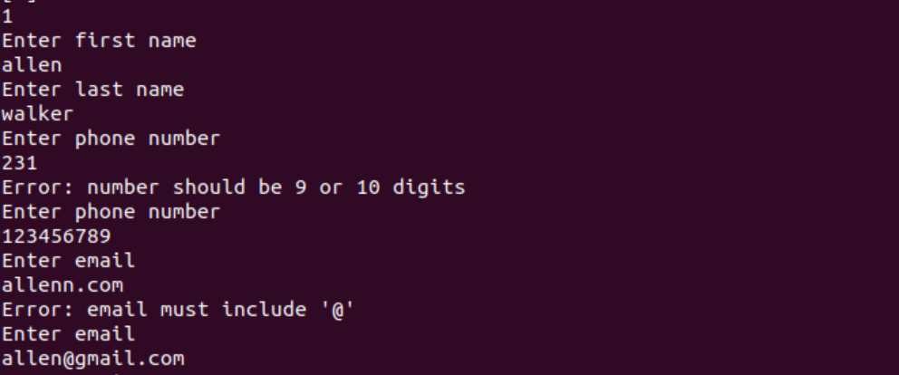

Fig.1.3

# Task 2(Sorting and Listing all contacts):

When the user enters number 2 which is for sorting and listing all data, it works as follows: sort the contacts.txt’s contents by using ‘sort’ command and save the output in a file we made it before named sort.txt and contains :”First name, last name, phone number, email”. We made the program delete the line “first name …” with small letter f, so that it won’t be contained again in the file after sorting. After that we made the program list the contents of sort.txt script using ‘cat’ command. As shown in fig.2.1

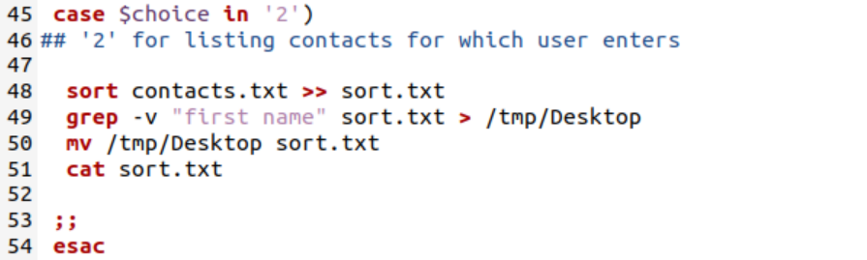

Fig.2.1

After applying it on the data we entered before in contacts.txt script as shown in fig.2.2 , we got the following results as shown in fig.2.3.

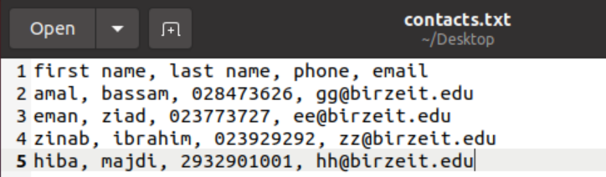

Fig.2.2

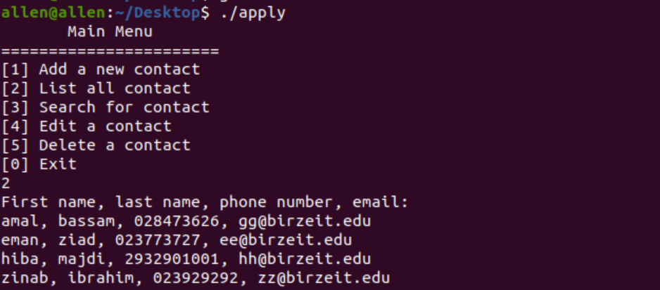

Fig.2.3

# Task 3(Searching for contact):

When the user enters ‘3’ for searching for any user. The program searches for any field: first name, last name, phone number, and email. So to apply that we made the program read what user inserts and using ‘grep’ command to get result of searching as shown in fig.3.1.

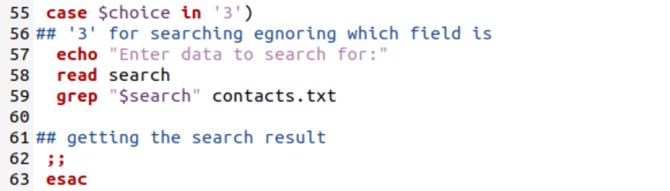

Fig.3.1

After executing it, we searched for ‘ziad’ which is in last name field, we got the result shown in fig.3.2



Fig.3.2

# Task 4(Edit a contact):

When user enters ‘4’ which is for editing a contact, the program asks for the name then do the following: repeat option 1 which adds a new contact then deletes the contact that was edited as shown in fig.4.1 and fig.4.2.

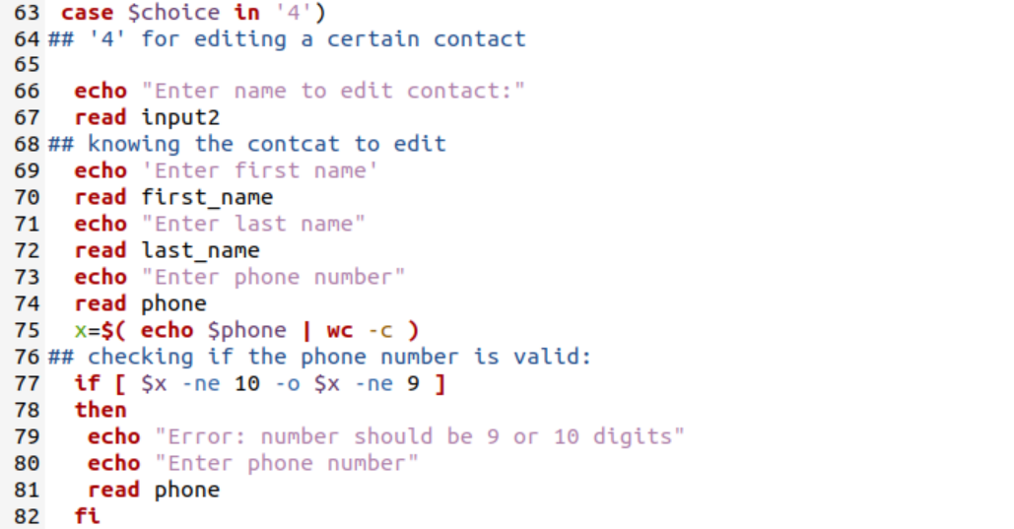

Fig.4.1

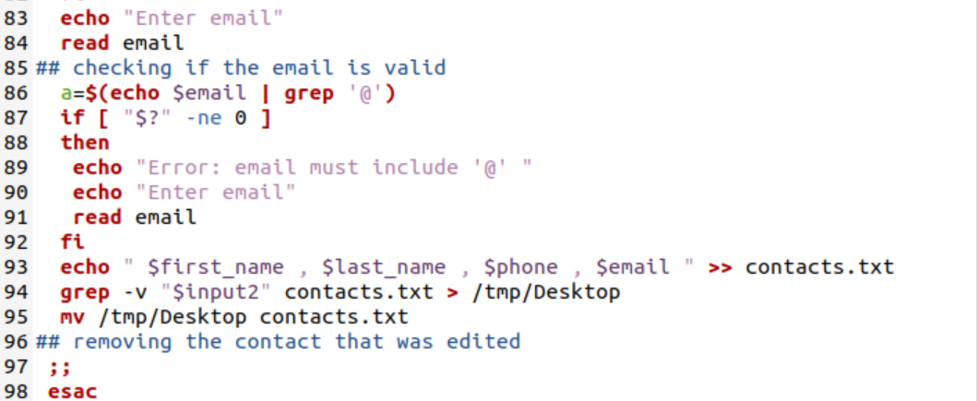

Fig.4.2

After executing the program we dot the following results shown in fig.4.3.

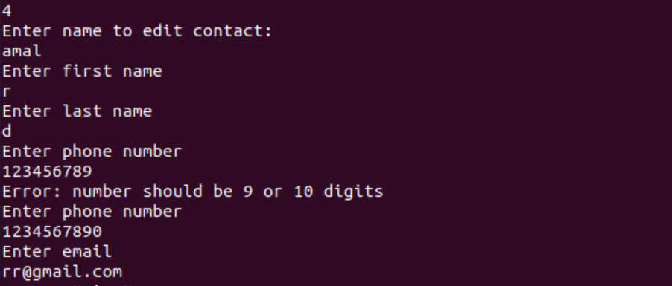

Fig.4.3

Then amal contact is not exists anymore as shown in fig.4.4.

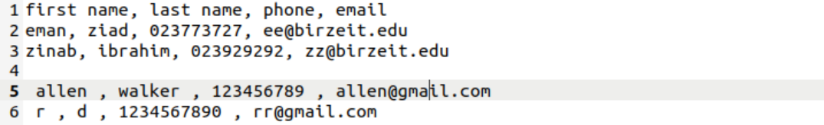

Fig.4.4

# Task 5(Delete a contact):

When user enters ‘5’ which is for deleting a contact. The program asks for the name to delete it. And by using ‘grep –v “$name” contacts.txt > /tmp/Desktop” command, it will delete the line of the name the user was entered in contacts.txt script and store it in /tmp/Desktop which the file direction is. And finally save the result by using “mv /tmp/Desktop contacts.txt” command. As shown in fig.5.1.

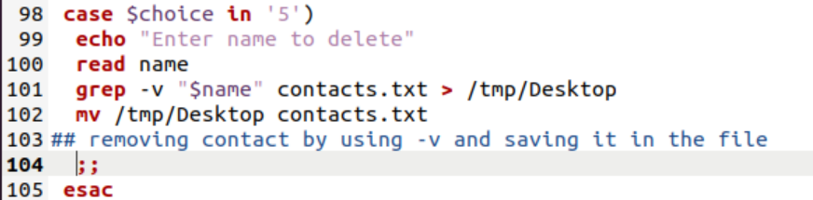

Fig.5.1

After executing the option and ask the program to delete the name ‘hiba’ we got the result as shown in fig.5.2.



Fig.5.2

Then see contents of contacts.txt by using ‘cat’ command as shown in fig.5.3.

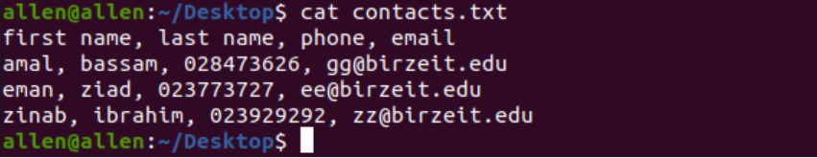

Fig.5.3

# Task 6(Exiting the program):

When user enters ‘0’ which is for exiting the program, the program will display a message “Good Bye” and then break the while loop using ‘break’ command. As shown in fig.6

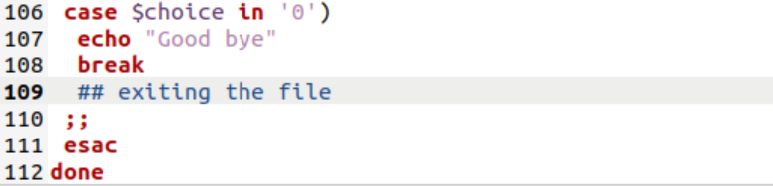

Fig.6

# Conclusion:

In this project, we have learnt how to do simple program that make operations of adding, sorting, editing, deleting, and searching for strings in a certain file. Also we got to know basics of using shell script in a way to get benefit of this in our lives in general and in many sides in special.